1. Circle Properties

1. Any triangle connecting two radius is a isosceles triangle

1. Equilateral Triangle

1. Central Angle

1. Semi circle

1. Chords Properties

1. Problem

1. Inscribed Angle

Inscribed angle arc theorem

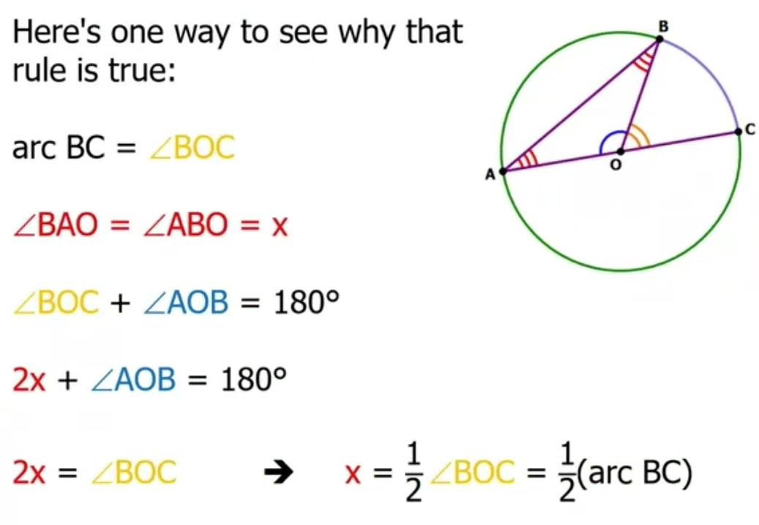

1. Right angle for inscribed angle

1. Two Inscribed angle

1. Problem

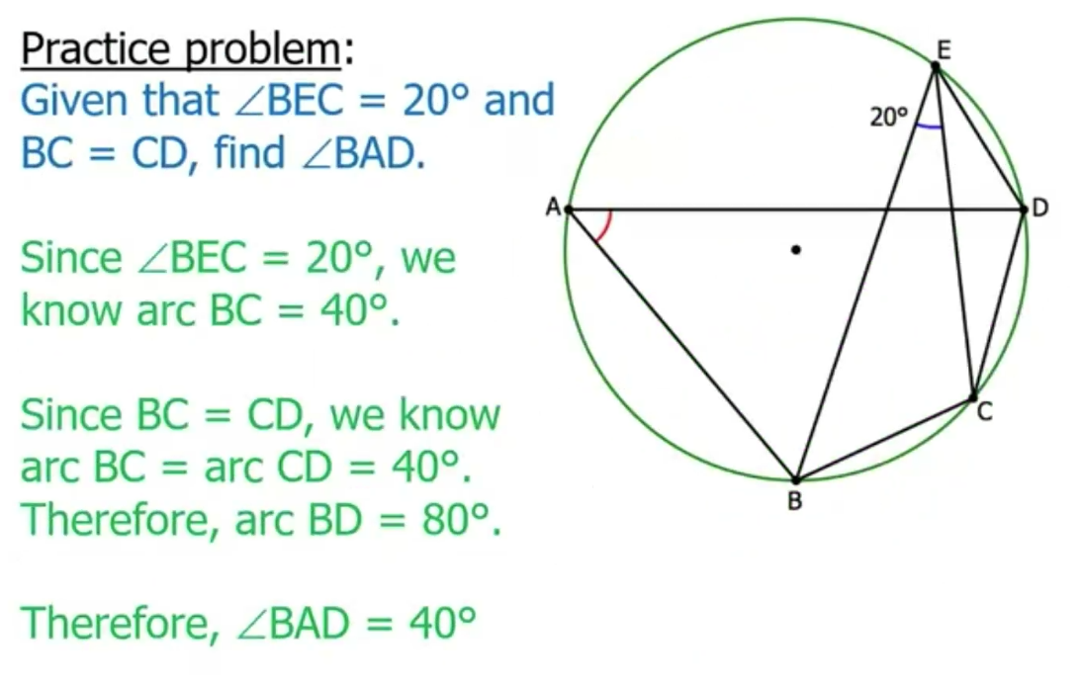

1. Tangent Line

1. Problem

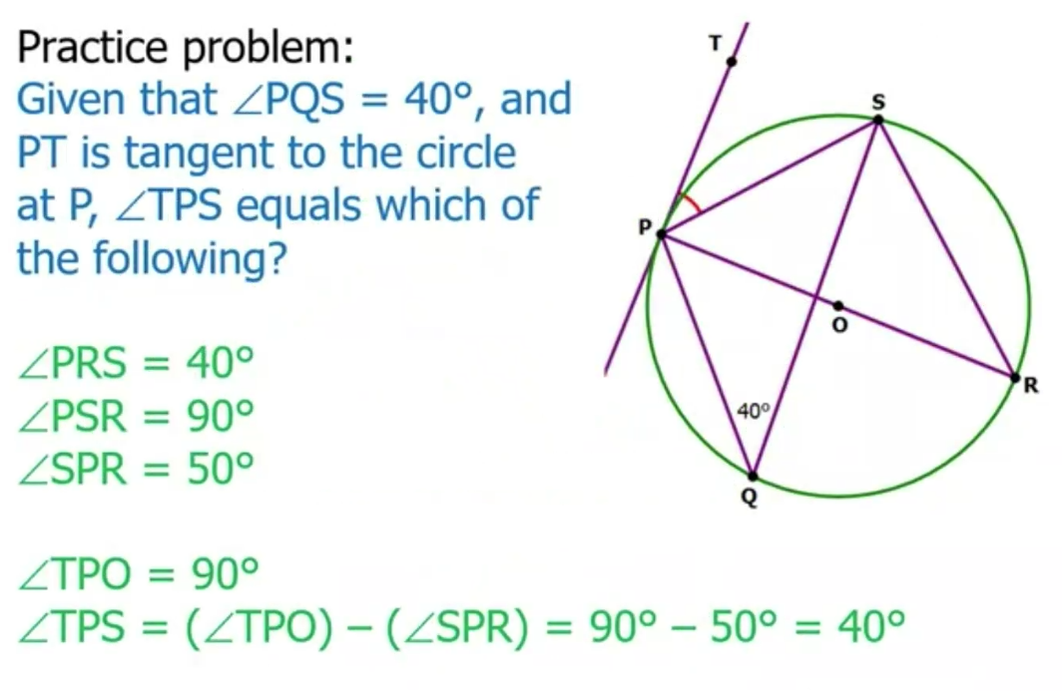

1. Summary

